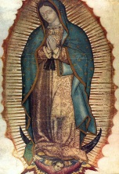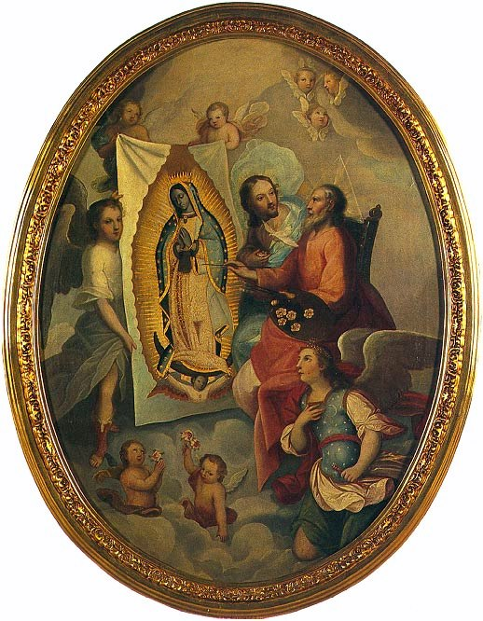
Our Lady of Guadalupe,

Save
U.S.!

Here is a beautiful song, we can sing and/or pray often in honor of The Blessed Virgin Mary, under Her title as our Lady of Guadalupe: Empress of the Americas, Queen of Families and Patroness of the Unborn. Her Feast day is December 12th.

[Thou] art the fountain of my life, Prayer to our Lady of Guadalupe:
Under [Thy] Shadow, in [Thy] Protection Our Lady of Guadalupe,
I fear no evil, no pain, no worry. Mystical Rose,
Make intercession for Holy Church,
Refrain: Protect the sovereign Pontiff,
Help all those, who invoke [Thee] in
O Maria, O Most Merciful Mother, their necessities,
Gentle Virgin, with the name Guadalupe, and, since [Thou] art The
On a mountain, we find roses in winter. Ever-Virgin Mary and Mother of The
All the world has been touched by Thy Love. ref. True God, obtain for us from [Thy]
Most Holy Son the grace of keeping
Here, in the crossing of [Thine] Arms, our faith, of sweet hope in the midst
Could there be anything else, that I need? of the bitterness of life,
Nothing discourage, nothing depress me. ref. of burning charity, and the precious
gift of final perseverance. Amen.
[Thou] art The Star of the ocean, (taken from: www/ewtn/com/
My boat is small and the waves are so high Devotionals/prayers/guad.htm)
…with [Thee] to guide me, I’ll reach my homeland. ref.

[Thou] art the dawn of a new day,
For [Thou] gavest birth to The Son of The Father.
All of my lifetime, I’ll walk beside [Thee]. ref.

Anonymous author. Melody of “Pescador de hombres”. Taken from: http://www.scribd.com/doc/249602643/Hymn-to-Our-Lady-of-Guadalupe-Lyrics. Pictures taken from: http://saints.sqpn.com/our-lady-of-guadalupe-gallery/ For more info, see: http://www.ewtn.com/saintsholy/saints/O/ourladyofguadalupe.asp ©® format by The Holy Family House, A.D. 12/12/2014 and on. Can be copied with legible copyright & distributed GRATIS. See: TheHolyFamilyHouse.org.

