We Have To Act NOW!

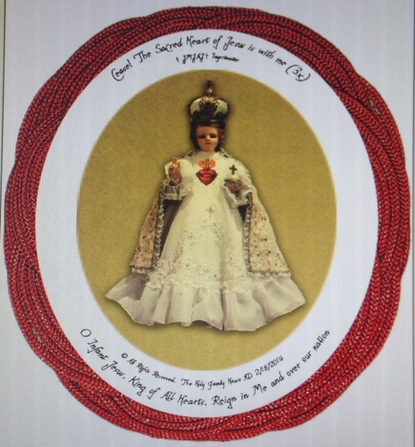

Do you like the things, that are going on now, in the U.S.? The Culture of Death, which pervades almost every area of our life? In the “land of the free and the home of the brave”, the most dangerous place for a person is in his mother’s womb. Now, increasingly, the most dangerous place for an elderly, sick, or handicapped person can be a medical, nursing, or hospice facility. If we don’t have the right to life, we will never be able to enjoy liberty or pursue happiness.

As God blesses or curses a family, according to the father’s behavior, so God blesses or curses a nation according to how its spiritual fathers, the Catholic Bishops, behave. As the U.S. Catholic Bishops have not efficaciously opposed the Culture of Death, The Lord is chastising the U.S. What can WE do? Let's look at another country, being chastised by Jesus:
Jesus Christ appeared several times to St. Margaret Mary Alacoque. “Jesus told St. Margaret Mary: ‘The Eternal Father…wishes to make use of the reigning monarch of France (Louis XIV) to proclaim public devotion of reparation to The Sacred Heart”. He asked that the king erect a shrine in which a picture of His Divine Heart would receive homage, and that the king request the Holy See to authorize the Mass in honor of The Sacred Heart. In return, Our Lord promised that the king would have His blessing and protection from all his enemies.” (http://www.thecatholic travelguide.com/ParayLeMonial.html) When the King refused to do so, France was soon beset by wars, and around 100 years later, A.D. 1789, the French Revolution tore France apart and began changing it from a Catholic country to a secular one.

Later on, in A.D. 1871, when the Germans had almost overrun all of France, the laity petitioned the Archbishop of Paris to enthrone Jesus’ Most Sacred Heart as King, over France. Incredibly, the Germans refrained from taking over France.

Recently, Pope Francis called for Catholics to pray and fast to block pres. Obama from sending U.S. forces into Syria, and we were successful. DON’T sit by and watch the U.S. go down in flames – let’s recognize and celebrate Jesus’ Divine Right to reign over us and be blessed - not chastised - by Him.

PRAY: www.theholyrosary.org/MaryUndoerKnots and make the novena, NOW, in honor of the Feast of Mary and Joseph's Espousals (January 22/23) when the core of The Holy Family was formed, to inspire Archbishop Kurtz, the Papal Nuncio, and other U.S. Bishops, in union, to have a Eucharistic Procession, to enthrone The Infant Jesus' Most Sacred Heart over the U.S., from the White House, past the Capitol, in front of the Supreme Court, in Washington, D.C., ASAP!

FAST: Give up a food/drink, un- necessary to good health, and offer this up for this Eucharistic Procession/ Enthronement to take place, NOW!

Fax/Write/E-mail/Call your Bishop, Archbishop Joseph E. Kurtz, D.D., of Louisville, USCCB President, & the Papal Nuncio, and urgently request that they make this Eucharistic Procession/ Enthronement, NOW!

Copy & Distribute: the attachment.

E-mail this web address to your list: http://www.TheHolyFamilyHouse.org/ Christus-Rex/

Contact: Catholic students, Priests, Deacons, religious communities,…

© & All Rights Reserved, The Holy Family House, Feast of our Lady of Hope at Pontmain, A.D. 1/17/2014 and on. Can be copied & distributed with legible attribution +A.M.D.G.
e-mail us: JMJAJ@TheHolyFamilyHouse.org

