What do you want to get out of LENT?

Your answer should be HEAVEN.

Why did God make us and every rational being? KLSO - to Know Him
to Love Him,
to Serve Him, &
to Obey Him.
What do we get if we do so? HEAVEN

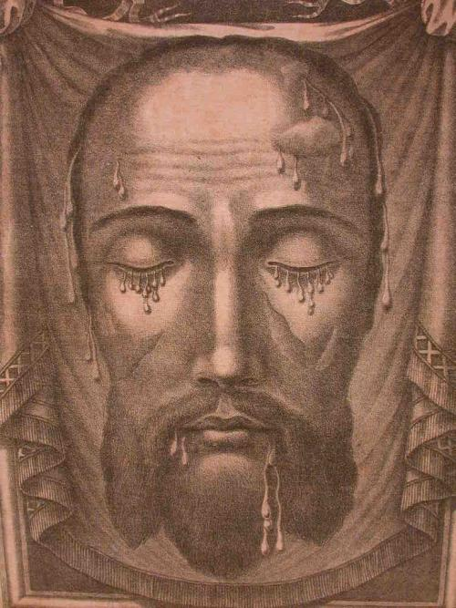

What is so great about Heaven? Since God Is The Only Being, Who makes us perfectly happy, when we die and go to Heaven, we see God, Face to face, and we enjoy perfect peace, happiness, and joy, not for just a few moments, but for all eternity, which never ends.
How does Lent help us to get to Heaven?
Lent is the most important Season of Grace all year. During Lent, we are to change, to imitate our Lord more closely, and, thus, become closer to Him. When we repeat our Baptismal Vows at Easter, we will be able to actually keep them. If we live and die, doing so, we will receive our reward for a life lived with God here on earth: a holy, happy death, which allows us to go straight to Heaven with no stops along the way.

We should follow a “M.A.P”. to the empty Tomb, from whence our Lord triumphantly rose from the dead, at Easter. Fill in the following lines with your Lenten objectives:

M = Mortification: ____________________
A = Almsgiving: ______________________
P = (extra) Prayer: ____________________

M = detach ourselves from material things and attach ourselves ever closer to God and to the things of God. Mortification, which means dying to the flesh, helps empty us somewhat of our material desires and helps us to be more open to the whisperings of The Holy Spirit. We are also trying to imitate Jesus Christ’s example when He fasted from food and water for 40 days before He began His Public Ministry on earth. He did not need to fast - He was perfectly detached from all earthly things, but He Is The Way we are to live and die holily, so He gave us The Example to follow when He fasted. We can abstain from more than one thing, which is not absolutely necessary to eat or drink, for good health, and it can include smoking, as well. We can begin any good habit or begin to get a handle on any bad habit, during Lent. The more difficult it is, the more The Lord will appreciate our sacrifice and reward us for it.
A = giving alms/donations to or making acts of charity to our neighbors. Our Lord Jesus Christ lived on donations/alms during His Public Ministry, yet He still had the person, who controlled the purse, give money to others, who were poor or in need. Our Lord did this, even though He did not have a home in which to live and often slept outside on the ground. This should show us that we all have something we can give to our neighbors. If we cannot give money or material help, we can pray fervently, daily for those we meet and those we don’t even know, who are our neighbors. One of the six Precepts of The Church is to support our parish, which includes monetary help. Our neighbors are those, who are in need and who are our enemies. Our Lord showed us how to treat our enemies/neighbors, when He said to The Father from The Cross: “Father, forgive them, for they know not what they do.” He forgave those, who were torturing Him, murdering Him, spitting upon Him, blaspheming Him, even though they did not ask or want His Forgiveness. If we do not show Mercy to or forgive those, who hurt us, God will not show Mercy or forgive us - as shown to us in the “Our Father”.
P = If we do not pray, we cannot reach Heaven. Why not? We cannot reach Heaven on our own - we have to rely on help from God, often through His Saints, to reach Heaven. How do we obtain this help? Well, naturally, we want to do what we want to do, when we want to do it, and where we want to do it - that is our will - what we want and don’t want to do. But, we can only get to Heaven by doing God’s Will, so how do we find out what His Will for us is, and how do we get the power to go against our wills to do God’s Will? We learn our Faith - memorize The Ten Commandments, which are written on each person’s heart and are our elementary guide to a holy life. When we have managed to keep, The Commandments, and go frequently to Confession - weekly - to reconcile ourselves to God when we fall, then, we try to live out the New Commandments of The New Testament/ Covenant - The Beatitudes. We can only live out well The Beatitudes if we are drinking regularly and frequently from the wellsprings of grace, which are the Seven Sacraments. Through the Sacraments, which our Lord instituted, we receive grace - the power to do God’s Will – to imitate Him.
Through Baptism, we become adopted Children of God. The heavy burden of Original/ Deadly Sin, which darkens our minds and weakens our wills, is lifted off of our souls, so that we can see what is right and wrong and choose to do the right more easily. Our Lord also gives us the theological virtues of Faith, Hope, and Charity – supernatural gifts.
According to Proverbs 24:16: For a just man shall fall seven times and shall rise again...” Thus, as our Lord knew that the majority of us would sin several times a day, He wanted to give us a means to make it up to Him for our betrayals and to become His close Friends again, so He gave us Confession or Penance (St. John: 20:21-23). This is an incredible gift, which nothing can buy - peace with God.
The Most Holy Eucharist is our daily, spiritual Food, our “daily Bread” – Jesus-Looking-like-Bread and/or Jesus-looking-like-Wine, which strengthens us spiritually, so that we can imitate God and become ever closer to Him, each time, we “commune” with Him.
Through Confirmation, God makes us soldiers in Christ, and He gives us the Seven Gifts of The Holy Ghost: Wisdom, Understanding, Counsel, Fortitude (or Courage), Knowledge, Piety - Love of God - and Fear of The Lord.
Through Holy Orders, God gives us spiritual fathers, called by God to consecrate their lives to leading us to Heaven: Priests, to teach us, to govern us, and to sanctify us, to help us to become Saints.
Through Holy Matrimony, The Holy Ghost descends upon a validly baptized man and woman, who are in a state of grace/friendship with God, for whom no impediments exist, and The Holy Ghost gives this couple the grace to remain together for the rest of their lives, to live at least civilly with each other, to help each other to be good, to become Citizens of Heaven, along with raising their children to do so, as well. In this way, the Kingdom of Heaven is built up.
The Anointing of the Sick is administered by Catholic Priests to Catholics, who are in danger of death or who are dying. If the Catholic is cognizant, he should make a good Confession; then the Priest will forgive his sins and anoint him, so that if he were to die at that very moment, without sinning, even in thought, the Catholic would go straight to Heaven. Sometimes, the Catholic is healed not only spiritually but physically, as well. That is why if a Catholic is to undergo a dangerous operation, he should receive the Anointing of the Sick, first.
You might ask why the Sacraments were listed in the prayer section. Prayer is communication with God - to adore Him, love Him, ask for forgiveness, and finally petition Him for our or others’ needs. Prayer should start in the morning and should regularly be done at various times throughout the day and night and in case of need. Prayer helps us to receive the Sacraments well, so that we gain the maximum amount of grace to do God’s Will - not ours - and get to Heaven when we die. Very important prayers include: The Most Holy Rosary, The Chaplet of Divine Mercy, The Way of The Cross, the Morning Offering, The Angelus, Acts of Faith, Hope, Charity, & Contrition, Holy Communion Prayers, Confession Prayers, The Holy Face prayers,…

Important Devotion to The Holy Face:

On November 24, 1843, Our Lord spoke the following words to the French Carmelite, [Bl.]Sr. Marie de Saint-Pierre: ‘The earth is covered with crimes. The violation of the first three Commandments of God has irritated My Father. The Holy Name of God blasphemed and the Holy Day of the Lord profaned, fills up the measure in iniquities. These sins have risen unto the Throne of God and provoked His Wrath which will soon burst forth if His Justice be not appeased. At no time have these crimes reached such a pitch.‘

Our Lord told [Bl.] Sr. Marie of St. Pierre on March 16, 1844: “Oh if you only knew what great merit you acquire by saying even once,

‘ADMIRABLE IS THE NAME OF GOD,’ in the spirit of reparation for blasphemy.”

“‘By offering My Face to My Eternal Father, nothing will be refused, and the conversion of many sinners will be obtained.’— Our Lord to [Bl.] Sr. Marie de Saint-Pierre (Nov., 1846). Our Lord appeared several times to [Bl.] Sr. Marie to ask for reparation to be done to His Holy Face. These revelations have the full approval of The Catholic Church.

The Holy Face Medal: Bl. Maria Pierina de Micheli (d. 1945, beatified May 30, 2010) was urged in many visions by The Blessed Mother and Jesus, Himself, to spread the devotion to The Holy Face. The Blessed Virgin Mary appeared to her, holding a scapular, which on one piece bore The Image from [Veronica’s Veil] with the words: “Illumina Domine Vultum Tuum super nos.” (“May The Light of Thy Face, O Lord, shine upon us.”) and on the other a [Sacred] Host surrounded by rays and the words: “Mane Nobiscum Domine.” (“Stay with us, O Lord.”)

Our Lady promised: “All, who shall wear a scapular like this and make, if possible, a visit to The Blessed Sacrament, every Tuesday, in reparation for the outrages, that The Holy Face of my Son, Jesus, received during His Passion and is still receiving in The Holy Eucharist, every day, will be strengthened in The Faith and be made ready to defend it, will overcome all difficulties, internal and external, and will have a peaceful death under The Loving Gaze of my Divine Son.” [Bl.] Sister Maria Pierina felt inspired and obtained permission to have a medal cast,… The first medal of The Holy Face was offered to Pope Pius XII, who approved [them]. On April 17, 1958, he declared the Tuesday before Ash Wednesday (Mardi Gras/Shrove Tues.) as the Feast of The Holy Face of Jesus,… (taken from: http://Church Militant.com/devotions/Holy-Face-Devotion) Pray these prayers daily for the Pope & US Bishops & The Sacred Heart Enthronement! (for more info on this necessary Devotion go to: TheHolyFamilyHouse.org/The-Holy-Face-of-Jesus-Mardi-Gras) E-mail us at: JMJAJ@TheHolyFamilyHouse.org

Can reproduce gratis with legible copyright. © & ®, The Holy Family House, A.D. 2009 & on. +A.M.D.G.

